BTEC Learner Assessment Submission and Declaration

When submitting evidence for assessment, each learner must sign a declaration confirming that the work is their own.

Learner Name: | Sebastian Archer
Assessor Name: | Scott Russell
BTEC Programme Title: | BTEC L2 Information Creative Technology
Unit or Component Number and Title: | Unit 13 - Website Development
Assignment Title: | Assignment 1 – Investigate the features of two websites
Date Assignment Submitted: | 02/03/2022

Please list the evidence submitted for each task. Indicate the page numbers where the evidence can be found or describe the nature of the evidence (e.g. video, illustration).

Assignment task reference | Evidence submitted
A.P1
A.M1
A.D1

Learner declaration

I certify that the work submitted for this assignment is my own. I have clearly referenced any sources used in the work. I understand that false declaration is a form of malpractice.

Learner signature: Sebastian Archer Date: 02/03/2022

Task One:
This is a hyperlink that will take you to the home page

YouTube

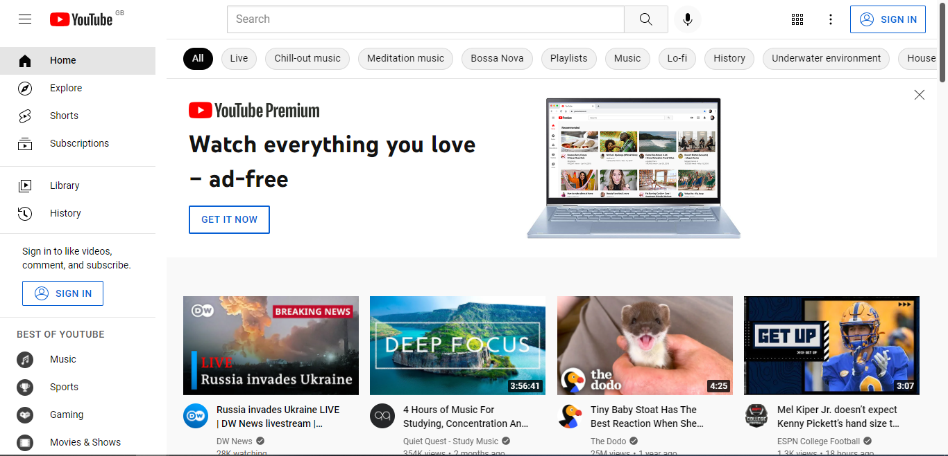

This is a video, it acts as a hyperlink and also has an embedded video as a preview
This is a search box to find videos on the site that people have uploaded

(Continue)

Google
It’s used as a search engine.
It’s full of hyperlinks to add to the page’s functionality.
It allows you to sign in to access user account history and extra functionality such as account services.

This is a hyperlink to take you to the sign in page in order to access your account
This is a hyperlink to search the web for whatever you typed in the search

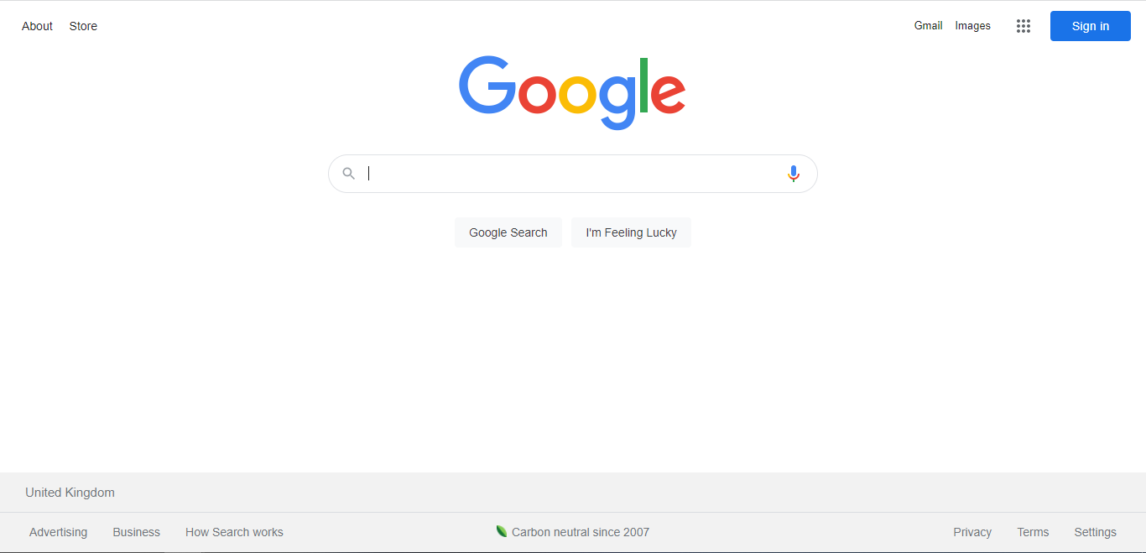

This is a hyperlink that takes you to the page settings

Task Two:

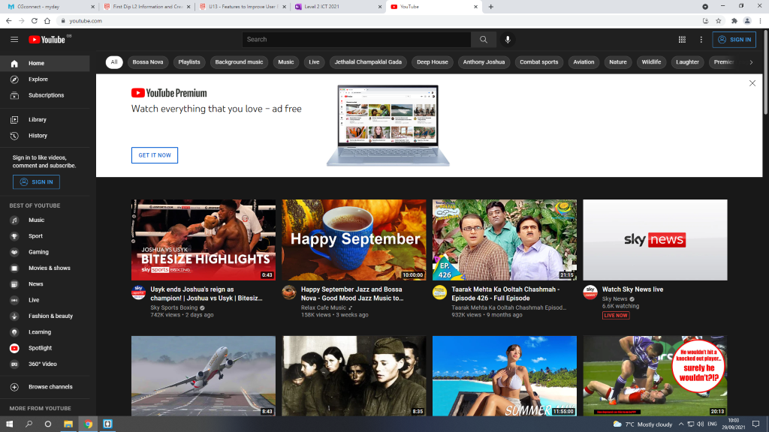

Useful:
This website is useful to everyone because it contains a various number of videos that people can watch whenever they want, the number of videos is endless and there's content that everyone can enjoy.

Findable:

There are many aspects to YouTube that helps its users find what they want to use, for example there are different category buttons at the top of the page for things like music, or different kind of sports or playlists. On the left side there are also different categories of videos to watch, and if you had an account, you could view your saved library or see video history.

Credible:

YouTube itself could not be considered a credible source because anyone is able to upload videos and spread misinformation if the video gains popularity. Websites like YouTube and its functions are generally abused for this because it is easy to reach people with different kinds of videos.

Task Three:
This website has a simple colour scheme, which is red and white. It is very popular amongst most people, and people watch multiple videos daily on the platform.

Strengths of YouTube:
YouTube is free to use for everyone, but there are a few videos that you have to pay for, but it’s very unlikely you’ll come across one unless you’re specifically looking for it.
You’re able to earn money through your videos through revenue, it depends on many views, likes and subscribers you have on your channel and your videos.
It’s very easy to use, even someone who doesn’t understand how to navigate or use computers well could understand how to use YouTube with ease.

Weaknesses:
Everything is public, you don’t really have any privacy on YouTube because almost everything you like or save is public. You have the option of hiding this, but if you don’t hide it then it will show on your public profile.
There are a lot of rules to follow when you upload a video, a big one is the copyright rule. You aren’t allowed to upload any copyrighted content.
Your account can be disabled without warning and it can be very hard to regain access to your account and personal content.

